## **Assignment - 01**

# **Find-VMX-Features**

This assignment is to develop a Linux kernel module that will consult a number of MSRs to determine the virtualization capabilities of your CPU.

At a high level, we need to perform the following:

• Configure a Linux machine, either VM based or on real hardware. You may use any Linux distribution you wish.

• Download and build the Linux kernel source code

• Create a new kernel module with the assignment functionality

• Load (insert) the new module

• Verify proper output in the system message log

Step 1: Create a VM on GCP (Google Cloud Platform) and enable the setting for nested virtualization.

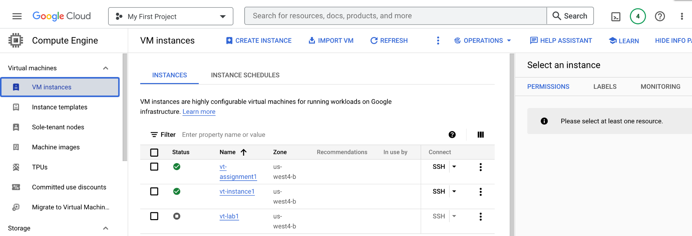

Step 2. Download the cmpe283-1.c source file and Makefile from canvas



Step 3. The functionality to query all the other MSRs as explained in the assignment description is added to cmpe283-1.c

By referring Intel SDM, created structures with name (description) and bit positions for primary procbased, secondary procbased, tertiary procbased, entry and exit controls.

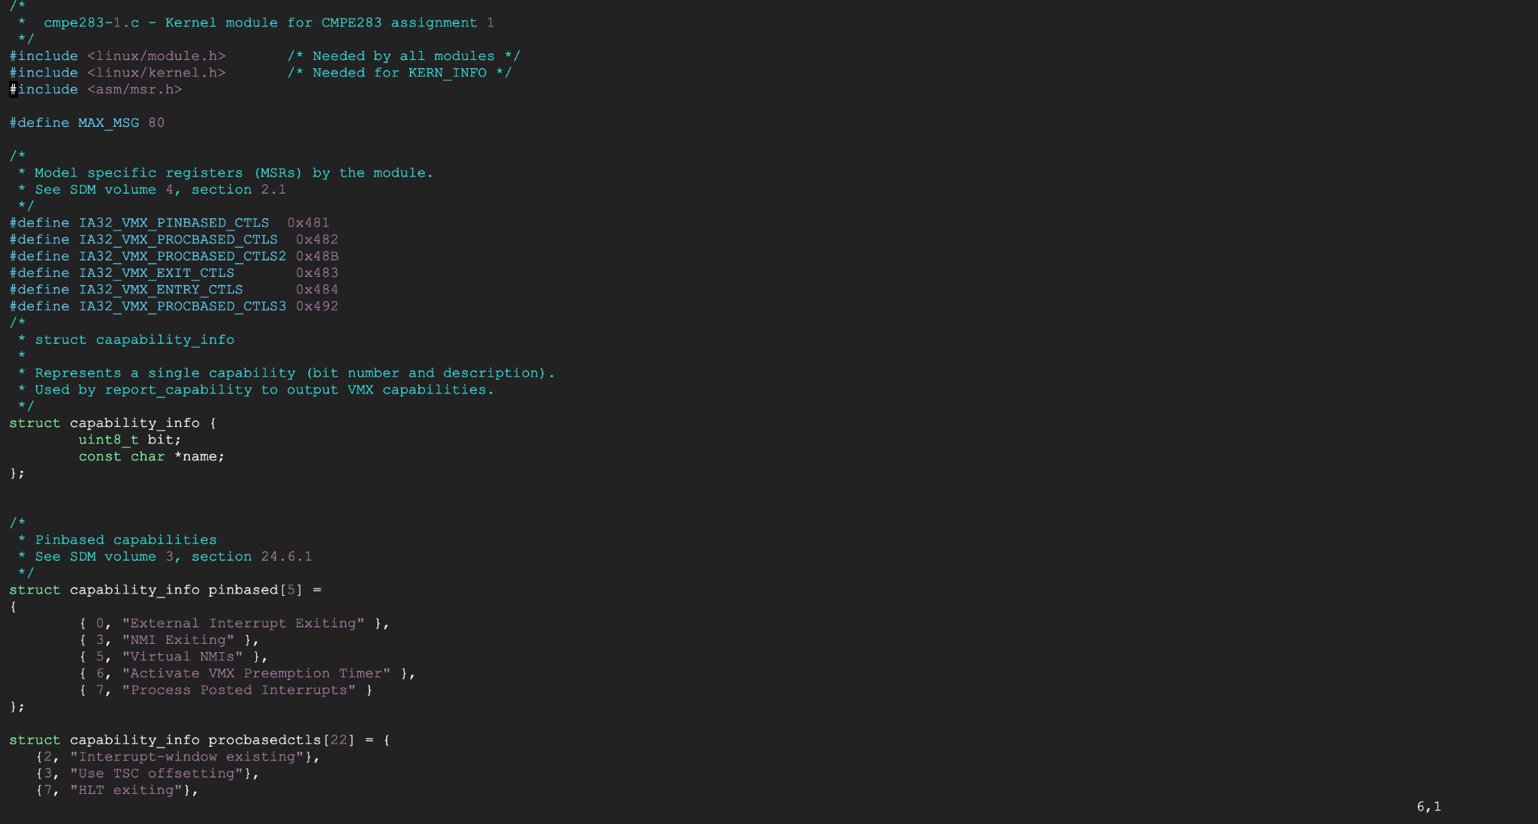

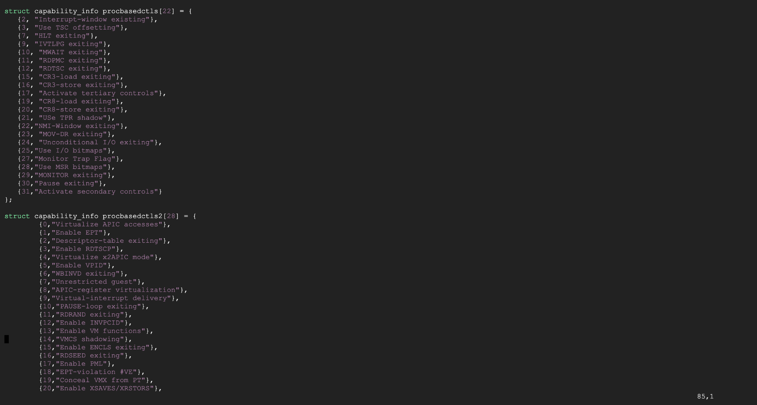

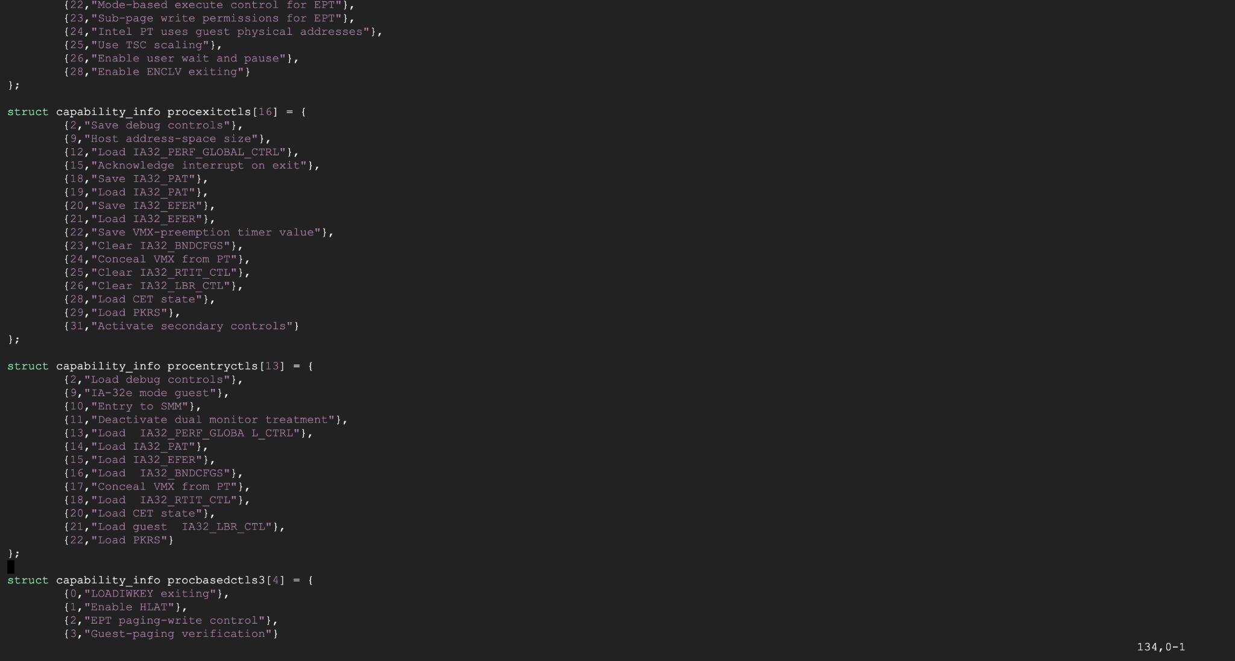

The function report_capability () is called with the necessary parameters given in order to print pinbased, procbased, entry and exit controls in order to identify and print VMX capabilities of the CPU.

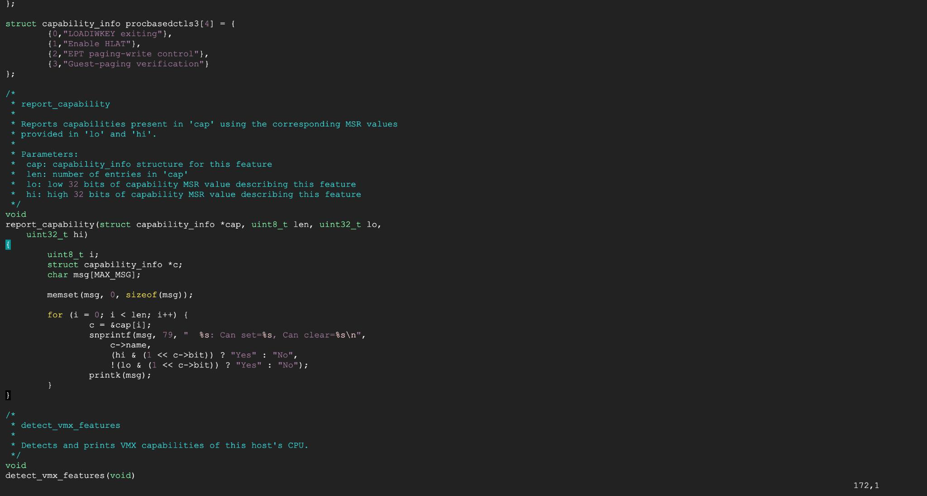

A new function detect_vmx has been written to examine the bit of the VMX MSR to see if true controls are accessible. If this bit is set, then true controls are available and another function will be called to print the corresponding true VMX capabilities. Similarly a new function is written for each controls and message is printed for true VMX capabilities.

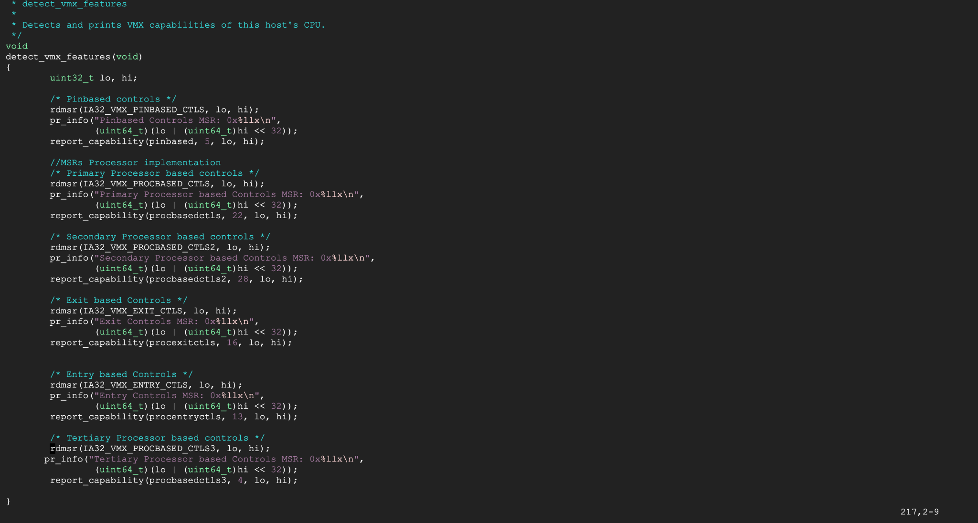

Install packages

1. Sudo apt install gcc make
2. er_priyagupta123@vt-assignment1:~/cmpe283-1$ make

After running make command, couple of files .o/.ko files will be generated d.

To insert module use below command

1. er_priyagupta123@vt-assignment1:~/cmpe283-1$ sudo insmod ./cmpe283-1.ko
2. er_priyagupta123@vt-assignment1:~/cmpe283-1$ sudo dmesg

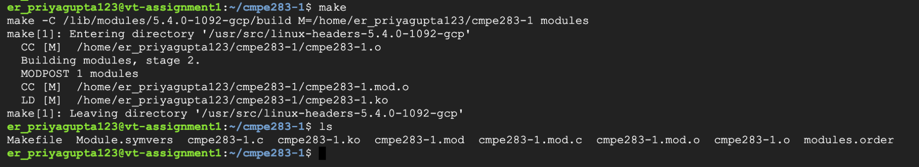

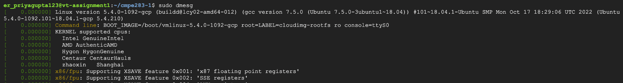

The output for the file is shown in the below screenshots

